34.36: 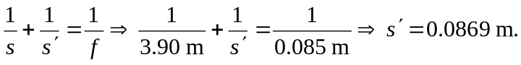
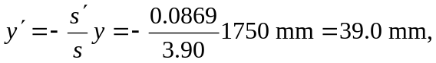so it will not fit on the 24-mm
36-mm film.

